**CHAPTER THREE**

**METHODOLOGY**

1. **OVERVIEW OF THE WORKING PRINCIPLE OF THE WEBSITE**

The architecture that enables the website to perform functionally requires that the website is reposed on the web server/broker (Apache) and an interpreter is required to translate the instructions from users through the browser (PHP in HTML) in communicating with the database. The browser interfaces the course materials with the users which in turn download or use the materials as required. This architecture is illustrated in the fig. 3.1 below

MySQL  
Database   
Server

PHP Interpreter,  
Apache Web Server

HTML

Web markup

Web Browser

User Interface

*Figure 3.1 Server architecture*

**3.1 CHOICE OF TECHNOLOGIES**

For conveniences and effective performances based on the operating system that will be used in hosting the e-learning platform, certain technologies are employed depending on the structure, performance and ease of use.

**3.1.1 CHOICE OF WEB SERVER**

Apache is more widely used than all other servers combined. Apache is blazing, and that’s what a web server should be, it should be simple, easy to use and fast.

* + 1. **CHOICE OF SCRIPTING LANGUAGE**

Choosing a scripting or tag-based language to use depends on the server technology available on your server:

1. PHP support is available on a large set of platforms (Linux, Windows etc) and a variety of web servers (Apache, IIS etc). So we get a choice of platforms and web servers for hosting the middle tier.
2. PHP support API’s for accessing a large set of databases, and it also support features like database persistent connection, easy APIs for cookies which will be used heavily in the middle tier of the application.
3. It is fast and easy to use: PHP has managed the perfect mix of power, structure and ease of use.
4. Cross Platform: PHP works as well on a variety of systems, OS and any other available products.
5. It accesses anything: PHP has a built in set of functions that make getting whatever you need very easy.
6. It is free i.e. open sourced and it is constantly being improved.
7. It is quick and powerful.
   * 1. **CHOICE OF DATABASE MANAGEMENT SYSTEM**

MySQL is a small, compact, easy to use database server, idle for small and medium size applications. It is a client/server implementation that consists of a server daemon MySQL and many different client programs. It is available on a variety of UNIX platforms, Windows NT and Windows 95/98. On UNIX platforms it uses threading which makes it a high performance and highly scalable database server.

The main features of a MySQL Database Server are described below:

1. Language Support: The database server MySQL can issue error message in various languages. MySQL by default uses the ISO-8859-(latin1) character set for data and sorting. The character set used for data and sorting can be changed while compiling the resources.
2. Programming language APIs for clients to access the database: MySQL supports client APIs for a large set of programming languages like Perl, C, JDBC, PHP, etc. Client programs which access data from the MySQL database can be written using these APIs – so more choices of programming language for implementing the middle tier.
3. Large Tables: MySQL store each table in database as a separate file in the database directory. The maximum size of a table can be between a minimum of 4GB and the operating system limit on the maximum file size
4. Speed, robustness and ease of use: MySQL is about three to four times faster than many other commercial databases. MySQL is also very easy to manage. You do not need a trained database administration for administering a MySQL installation.
5. Cost Advantage: MySQL is an open source relational database and its source binary code is open to whosoever wishes to develop on it on the condition that he/she will make it open to others after the development. So with MySQL you get a cost advantage over commercial relational database.
6. Highly scalable: MySQL is highly scalable and easy to administer. You do not need to train the database administrator for managing a MySQL installation. Not only is MySQL the world’s most popular open source database, it’s also become the database of choice for a new generation of application built on the LAMP (Linux, Apache, MySQL, PHP/Perl/Python) stack.
   1. **STEPS TAKEN IN THE DESIGN OF THE E-LEARNING PLATFORM**

The following procedure explains how the web application was designed and implemented.

1. The database “elearn_db” was created using the MySQL server 5.6.12. Various tables which hold related data in the database were also created.
2. PHP 5.4.14 interpreter was installed to interpret PHP codes before it will send the PHP codes and HTML codes to the web browser to display.
3. Apache HTTP Server 2.4.4 was installed to serve the web server that will serve any web page being requested by the client
4. The front-end/client interface is developed with Adobe Dreamweaver. It has a number of web pages ending in .php linked together. The user program can be deployed from any machine once hosted since it is meant to run a browser.
   1. **DESIGN AND IMPLEMENTATION**

The e-learning platform called “VirtualClass!” is developed using PHP which is embedded in HTML codes. The platform is designed with much consideration on security issues to avoid unauthorised users to obtain documents or lecture notes or unauthorised persons login through the admin login section. The web application which is currently hosted on localhost is developed using Content Management System (CMS) approach in which the lecturers are the content creator and the students as the content user/consumer.

To achieve this, the platform is thus divided into two distinct sections namely:

1. Student Section
2. Lecturer/Administration Section

**3.4 WORKING WITH DATABASE**

As mentioned in the previous chapter, databases are required in order to effectively manage the e-learning platform. Tables are required within the databases to efficiently hold the repository of certain platform files and documents such that all available documents are rendered online to users who desire them. Hence a database called “elearn_db” is created with several tables within the database construct.

It is important to note here that there is no direct access between users of the platform and the database in order to ensure maximum security for files and information required to keep the platform functional. However, users are still granted controlled permission to add information to the database but only in the case of creating accounts and a few other permissions that has been certified secured.

* + 1. **Creating the Database**

Database are created in two modes – offline and online. Offline mode requires that the server software is running on the developer’s machine. Databases are created by using PHPMyAdmin that is available with the installation of the LAMP package in EasyPHP. It’s a front end to executing SQL queries by clicking and writing queries if necessary.

The online mode of database creation requires a domain name registration for the repository website of the platform. The domain username and password supplied by the host upon registration of the domain is then used to access the domain control panel. The control panel is an administration control panel for managing a website. Databases can be created using the database wizard tool. The entity relationship diagram of the database used is as shown in fig. 3.2 below

As mentioned earlier, there is no direct access to the database except the administrator who creates the database. The platform itself has been fortified with scripts to connecting with the database, creating tables, querying, executing functions etc.

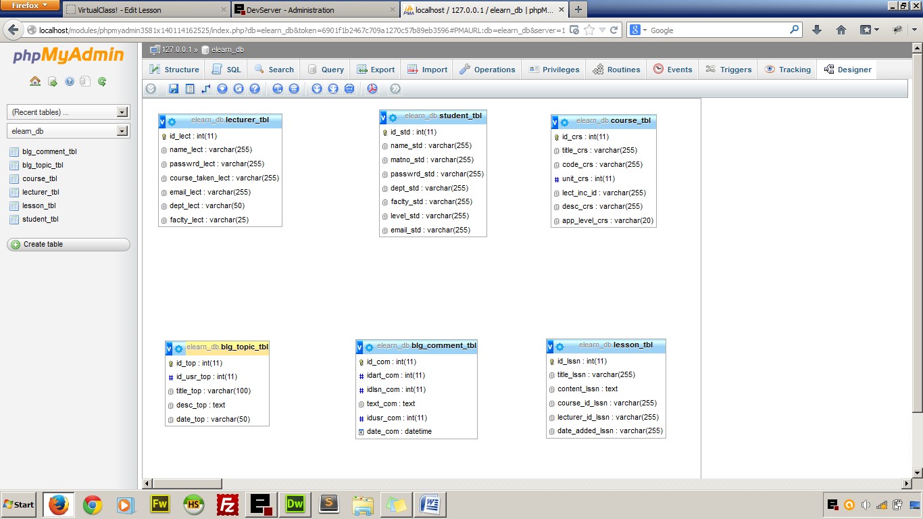

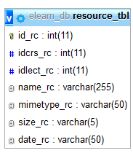

*Figure 3.1 Entity Relationship Diagram of the Database “elearn_db”*

**CHAPTER FOUR**

**RESULT AND DISCUSSION**

**4.1 STUDENT SECTION**

**4.1.1 LOGIN PAGE**

The login page is characterised by menu that the user can click to access other pages and a login form that is required before a user is authorised. The student is required to enter his or Matric no that serves as the username and password. A login session is set before a user is granted access to the resources that are available. The entered Matric No and password is validated against the user’s details in the database and if there is a successful match, the student is redirected to the student’s homepage.

In case of a mismatch an adequate error message is displayed.

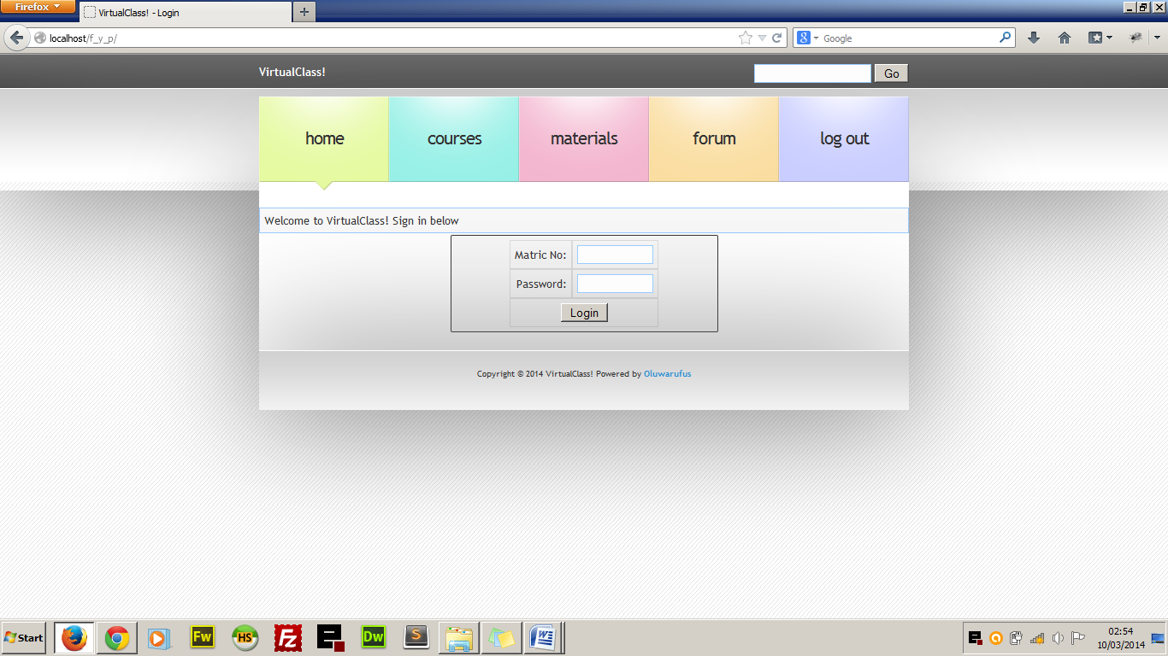

*Figure 4.1 Login Page*

**4.1.2 HOMEPAGE**

After a successful log in the user is redirected to the student’s homepage where resources can now be accessed because of the active log in. The homepage is characterised by a brief history of what the student can do with the web application. The homepage also have a list of the recent lecture materials that was added to the database by the lecturers and below the page is the details of the logged in student such as full name, department, faculty, matriculation number and current level.

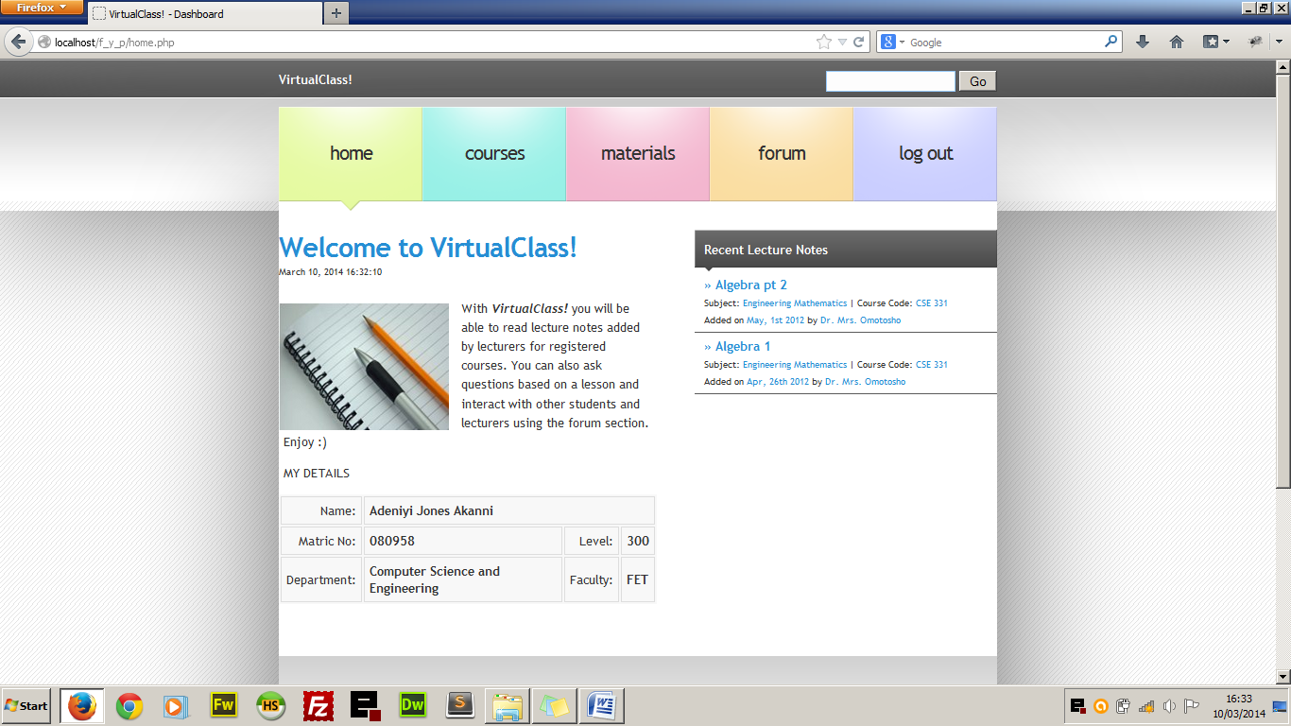

*Figure 4.2 Student Home Page*

**4.1.3 COURSES**

When the student clicks on course from the main menu, he/she is redirected to the page that contains all the registered courses with a brief introduction to each course, course code and unit, the lecturer-in-charge and the number of lessons under each courses. Clicking the course title takes the student to the page that contains all the lessons under the course starting from the latest to the oldest. This helps students to read only the latest lesson notes first.

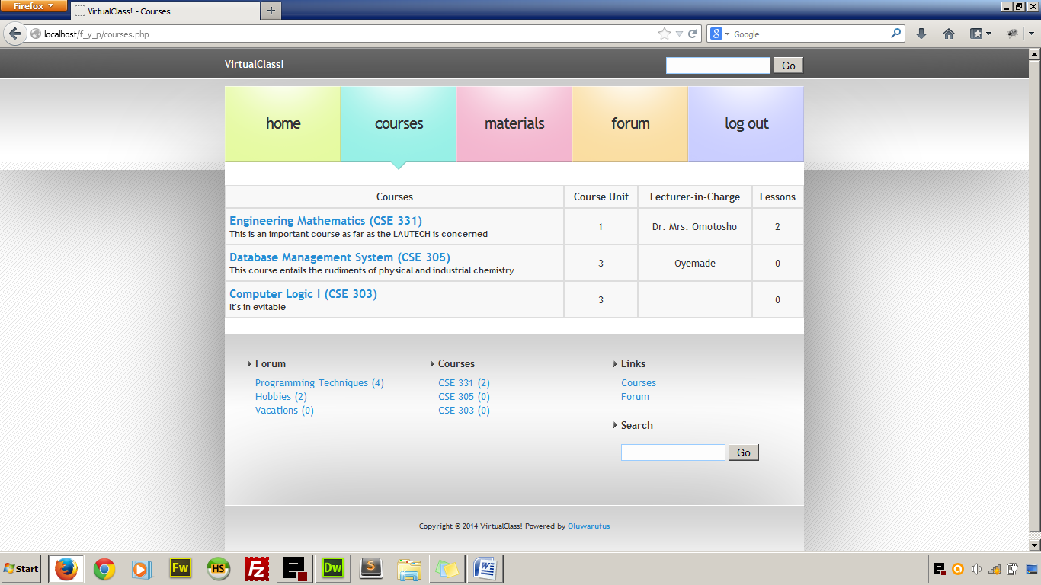

*Figure 4.3 Course Page*

**4.1.4 RESOURCES**

This is the page that contains all the uploaded media documents added by the lecturers that can be viewed online or downloaded for offline reading as the case may be. The managers (the lecturers) have the privilege to upload a document, audio or video.

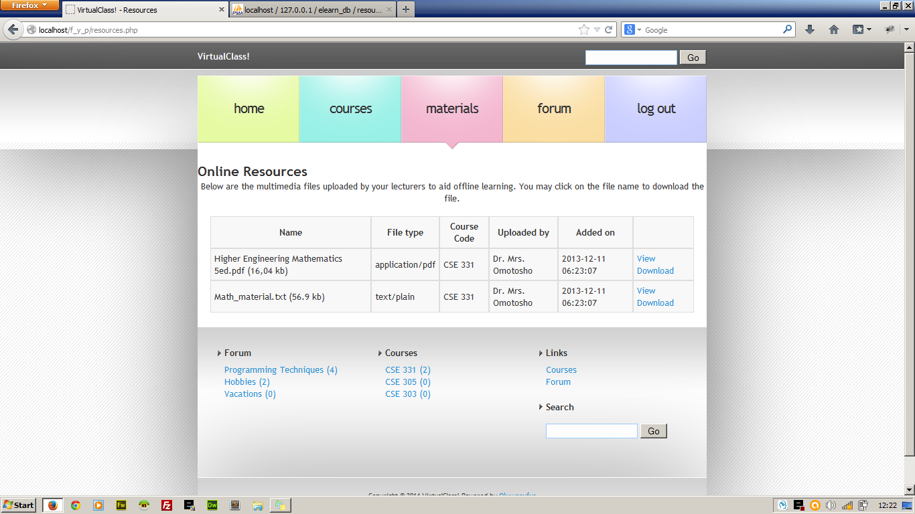

*Figure 4.4 Students’ Resources Page*

**4.1.5 FORUM**

This is where discussion is carried out within the e-learning system. Students can ask question based on anything and get their colleagues to discuss any trending issue. The lecturers serve as the Forum Moderator that delete or block any irrelevant forum topic.

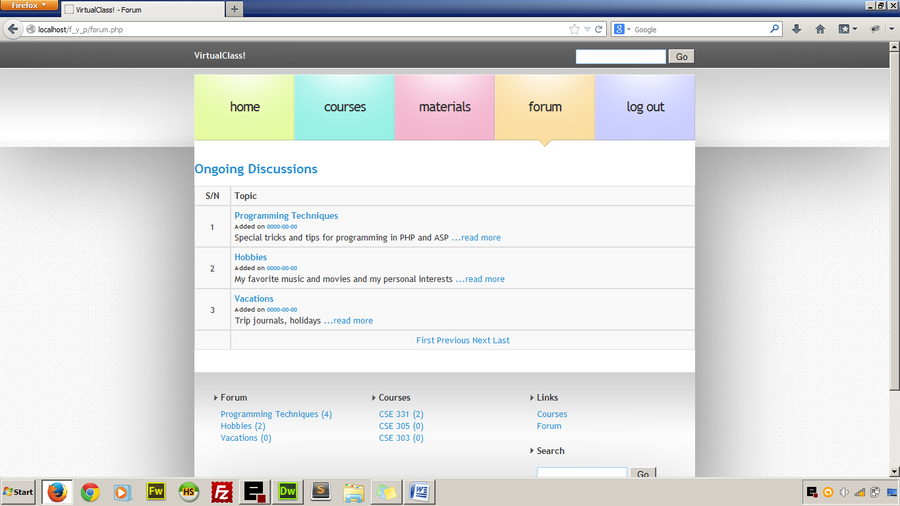

*Figure 4.5 Forum Page*

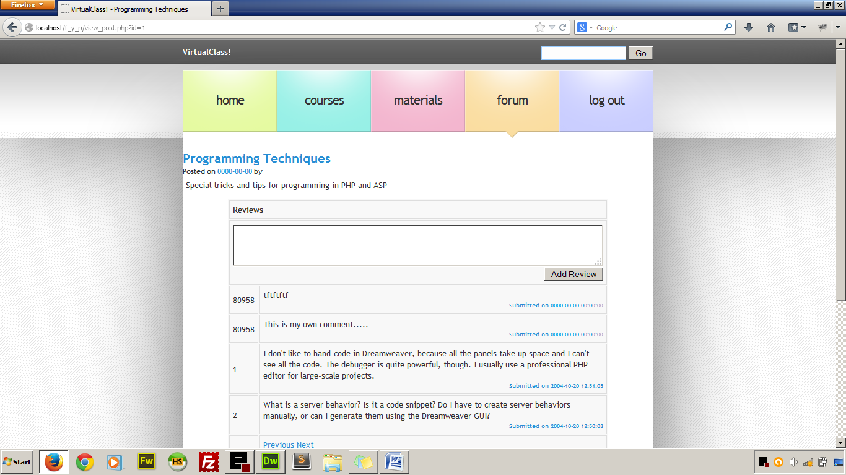

*Figure 4.6 Forum discussion page showing the review form*

**4.2 LECTURER SECTION**

The lecturer section is where the links to manage the courses lies and it can only be accessed using username and password given to lecturers. The username in the case of the lecturer is the email address of the lecturer and a predefined password. The lecturers’ section contains the tools in three subsections which include:

1. Course Lesson Management
2. Course Material Management
3. Forum Management

**4.2.1 COURSE LESSON MANAGEMENT**

The lecturer is able to manage only the course which he is assigned to. Management in the sense that lecturers will be able to add lesson notes to their courses, edit the lesson notes as the case may be and delete the lesson note if necessary. They will also be able to see comments posted by students to each lessson and reply if it is a question or delete from the database if it is a profane comment.

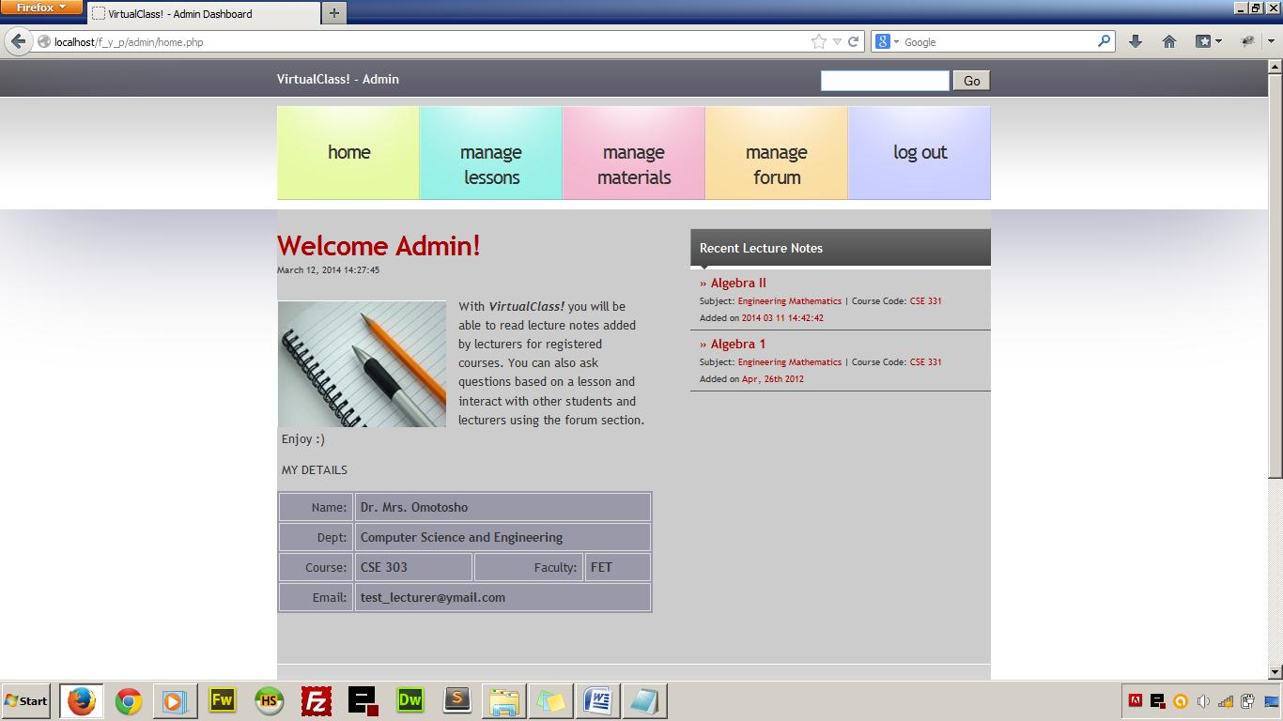

*Figure 4.7 Lecturer’s homepage*

**4.2.2 COURSE RESOURCES MANAGEMENT**

Lecturers using the web application will be able to upload files which could be normal documents or audio visual files that could help the student further in their studies. Lecturers are granted the privilege of adding and deleting as the case maybe. The uploaded material is bounded with the course that the lecturer is taking.

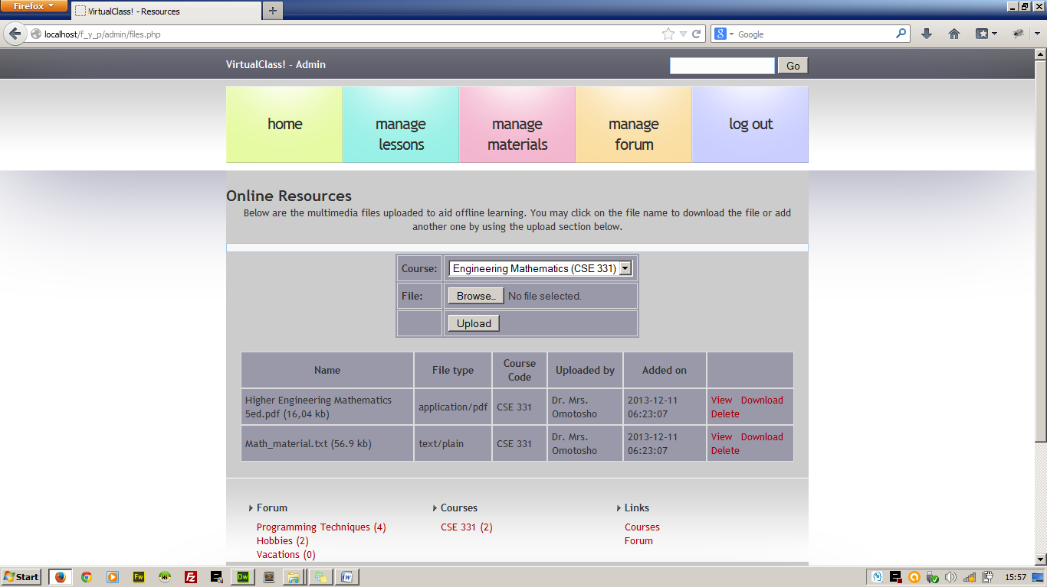

*Figure 4.8 Manage file page*

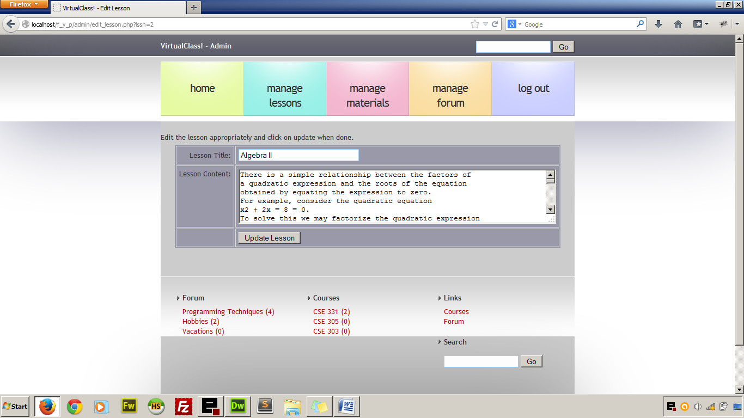

*Figure 4.9 Lesson updating page.*

**4.2.3 FORUM MANAGEMENT**

We can not deny the fact that there are always excesses when it comes to student giving reviews and comments and this is why lecturers are given the role of managing the discussion forum. They are given the privilege of deleting forum topics that are not educational and also delete comments that are irrelevant to ongoing discussion.

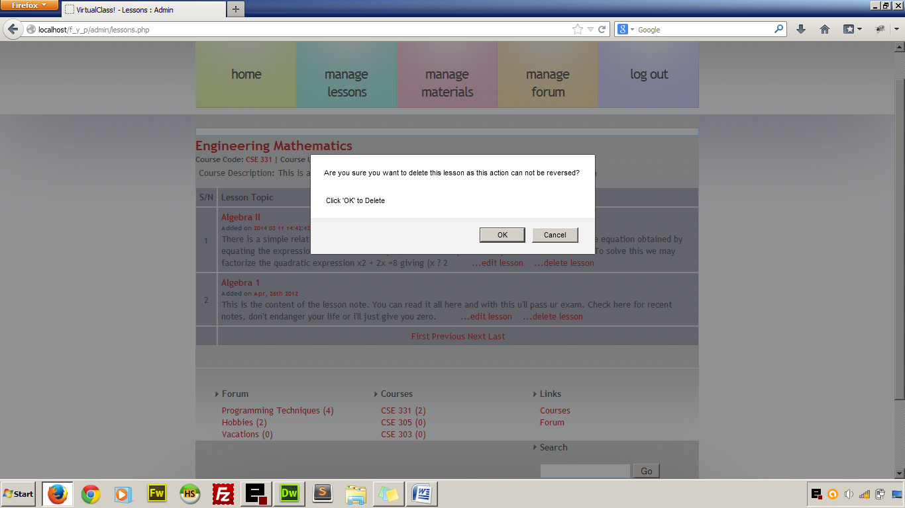

*Figure 4.10 Screenshot of deleting operation*

**CHAPTER FIVE**

**CONCLUSION AND RECOMMENDATION**

**5.1 CONCLUSION**

Conventional teaching system is still favourable in the tertiary educational system in Nigeria but a handful of universities have embraced online lecture delivery system in order to synchronize lectures and courseware materials for their distant learning students and for their in-campus students. The adoption of online synchronisation of lecture materials will adequately supplement the conventional face-to-face teaching system; most lecturers will find it easy to run online version of their courses and at the same time deliver face-to-face lectures at their convenience. For instance, in a course where most of the required materials have been given beforehand online, the lecturer will only need a class or two to explain course contents which will ordinarily take them eight to ten classes to explain. On the other hand, students will acclimatize quickly on the online environment and with formal adoption of this lecturing system, they will learn quickly and more efficiently.

This project is practical example of custom-built E-learning system that supports the academic curriculum in use in Nigeria. It is built to support integration with other educational web application such as online grading systems which could be deployed with it as the need be.

**5.2 RECOMMENDATIONS**

For smooth and effective online lecture delivery, the stake holders in the educational sector such as the governments, school management boards, parents, etc. are hereby enjoined to provide the following:

1. Adequate infrastructural facilities in universities to support online lecture delivery.
2. Adoption of the online learning system as part of the learning structures in the federation
3. Encouragement to students by making available affordable computer devices as well as internet connectivity.
4. Establishment of favourable technological policies that will increase the rate of ICT adoption.